Paradigm Concepts
Presents

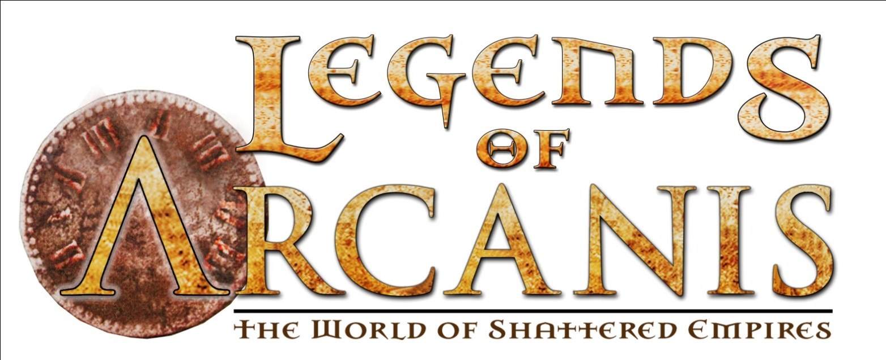

Cardakkx Rising

A 4-Hour Legends of Arcanis Adventure
Soft-Point Adventure 3, Crusades Year 1
Month, 1070 I.C.

by Scott Reid

As the Crusade pushes deeper into the Hinterlands towards the Infernal-controlled lands of the Lordship of Iron, the bloody sites of battles and skirmishes are becoming more common. These sites draw pilgrims, as they draw flies; but being so close to the front, the pilgrims must be protected.

This Legends of Arcanis Standard adventure is designed for Tier 1.

Credits
Author: Scott Reid
Story: James Zwiers
Editor: Anthony Nijssen
Cartographer: Pedro Barrenechea
Version: 2.0

Campaign-Related Information
This adventure starts at a forward-operating base established about two days travel outside of Sicaris. There are basic amenities here, but no formal temples, or other significant permanent structures.

Temples and Shrines
There is a small, crude, and obviously temporary shrine to Nier, Justicar of the Gods.

Organizations
There are no organizations involved in this adventure to which a hero may belong.

Adventure Background
The skirmishes of the Crusade have left a great many small battlefields scattered across the Hinterlands between Sicaris and the formerly Sealed Lands. Not all of these sites have become locations of holy pilgrimage, but those where great feats or noble sacrifices have been performed are drawing increasing numbers of pilgrims.

The Crusade Commanders are unwilling to allow large numbers of effectively unarmed pilgrims to travel on their own that close to the front lines. The pilgrims are gathered into groups and available Crusaders are assigned to protect them on their journey.

However, the Crusade is not the only group with its eye on the pilgrims. A Yhing-hir sect of the Seekers of the Hidden Masters has noticed this activity, and decided to make use of it. One of their ancient rituals, only recently re-discovered, is supposed to be able to summon forth a Devil King; this, of course, requires a large number of live sacrifices.

To that end, they have decided to capture two groups of pilgrims, killing the guards in the process. Two groups, around forty pilgrims, should give them sufficient sacrifices to ensure the ritual’s success (to the best of their knowledge).

At the beginning of the adventure, the Seekers have already waylaid one group of pilgrims (killing the Crusaders who were guarding them) and are preparing to capture the second group soon.

While normally the Crusade would be too pressed for manpower to search for missing pilgrims (despite their best intentions at keeping them safe), the first group of pilgrims included Sir Leopaeld val'Ossan, fifth-cousin to King Osric.

Adventure Outline
Introduction: A Hint of Blood: The adventure begins with the heroes on the road, bearing an important missive that must be delivered to the garrison commander at the forward-operating post outside of Sicaris. Along the road, they find a Crusader-scout, bleeding atop his mount and barely alive. He is all that is left of the guards for the last group of pilgrims that went out.

Scene One: Where There’s Blood…: The garrison commander is deeply concerned by the news the Crusader-scout brings back. Having accepted the missive from the heroes, he will request that they accompany the next group of pilgrims to the holy-site, and investigate this attack to the best of their abilities. He refuses to not send the pilgrims, as he does not wish to start a panic by revealing that anything is currently wrong. Should the heroes fail, he will be obligated to take more drastic action.

Scene Two: There’s a Wound: The journey to the holy-site, which lies three days travel to the northwest of the forward-base, is easy and tranquil. On the last day, the group is set upon by Infernal-tainted beasts, drawn to the recently slain Crusaders who were guarding the previous group of pilgrims.

Scene Three: A Hidden Slaughter: With the pilgrims at the holy site, and the other Crusaders guarding them, the heroes are free to do their investigating. They will be able to locate the corpses of the Crusaders who were guarding the prior group, as well as some clues that may assist them in finding the cultists.

Scene Four: A Deadly Bluff: The Crusade, desperate for bodies to fill armor, is not always particular when it comes to who they will take. Unfortunately, for the heroes, the other crusaders who are guarding this set of pilgrims are all members of the cult, and when the heroes get back to the main holy site, they find themselves set upon by the Crusaders, now that the pilgrims are safely captured. All that the ritual is waiting on, is the heroes to not be alive to interfere.

Scene Five: The Blood-Rite of Cardakkx: Following the trail of the captive pilgrims to the ritual location is simple. When the heroes get there, the ritual has only just begun. The heroes can intervene in the ritual at any point; the actual sacrifices will both be obvious, and at the end of the ritual, so the heroes do have some time to watch and plan (within reason).

Scene Six: The Grateful Horde: Having rescued them from the clutches of the cult, the pilgrims are grateful to the heroes. They will gladly accept any offers of escort back to the main Crusader camp.

Scene Seven: The Hidden Hand: If the heroes are astute, they may have realized that the cultists were not operating on their own. They may have realized that someone back at the Crusader’s main camp was involved. They don’t have enough information to track down who in specific, but they can present what they do know to whomever they desire to back at the camp; if they think to do so, (and even realized this is what was happening) they can present their information to the commander. He will have an idea who it is, and will ask if the heroes would arrest the individual.

Introduction:

A Hint of Blood
Key Concepts: The heroes are introduced, and a survivor is found.

There are a couple considerations here, before launching into descriptive text.

If all of the heroes at your table have previously played adventures in the Crusade Arc, assume they are members of Crusade (in one form or another), and are travelling to Sicaris bearing a missive for the Commandant of the Outer Sicaris Garrison.

If none of the heroes have previously played adventures in the Crusade Arc, then they have been given recruiting papers, and have been ordered to present themselves to the Commandant of the Outer Sicaris Garrison.

Missive Bearers
You’ve been on the road for the better part of a week, travelling in a small group headed towards Sicaris. Your commander tasked you and several of your companions with delivering an important missive to Captain Joren val’Tensen, the Commandant of the Outer Garrison at Sicaris.

New Recruits
Maybe it is the lure of glory, the promises of salvation, or the lust for battle; whatever the reason, you have elected to join King Osric’s Crusade. It is for this reason that you have been travelling towards Sicaris; you have been instructed to present yourself and your recruitment papers to Captain Joren val’Tensen, the Commandant of the Outer Garrison at Sicaris.

When the adventure proper begins, the heroes have been travelling together for several days; whether veterans or new recruits. Allow them to describe themselves and regale each other with a few short anecdotes of their past (or maybe hoped for) glories.

Once they have done so (or elected to not do so), continue with the following.

The late-afternoon sun is bright, shedding long-shadows of your party across the wide, shallow valley through which you are riding. The recent rains have given the normally dry hills a burst of color, as small shrubs and grasses take advantage of the rain.

Use a Passive Perception check to determine which hero notices the following first (use the highest result, or the one you feel would engage the players the most).

Ahead, near a shallow bend in the valley, you can just make out a horse standing beside the track. It is not clear, but it looks to be laden with bags.

As the heroes get closer, describe additional detail. The horse is laden, but not with bags. Rather, it has an unconscious man draped across it, and its rear flanks are covered in dried blood.

The man is still alive, barely, and given attention (and more importantly, water) he can be revived. Before getting too far along, the following is a complete description for when the heroes are close enough.

The horse you spotted before is a pale-cream colored stallion, except for its rear flanks that are an ochre-brown color. Clearly trained for battle and used to trouble, it eyes you as you approach. Draped across its back, over a saddle, is the slumped figure of a man.

Allow the heroes to make a Beast Lore (TN:5) or Empathy (TN:10) check to calm the horse and let them approach. If all the players fail, the horse will shy away from them.

The man is wearing a number of the insignia common to Crusaders, but also has a crest emblazoned on his arms of a crossed spear and staff.

Identifying the crest that is on both upper arms requires a Knowledge: (Military) roll (TN: 12). Success correctly identifies this crest as that of a Crusader-Scout.

A Heal (TN: 10) reveals that the scout is not dead, but is definitely not in good shape. It also reveals the reddish-brown color on the back of the horse to be dried blood (from the scout’s injuries). If he is given water and/or basic medical attention, he will revive.

If the heroes do not attend this individual, make note and be careful to modify the prepared text in the encounters that follow to account for the scout not being present.

Yaeger Bierkrutz
Human, Expert, d6, Skills (+4/18/12): Perception, Lore: Geography, Ride

Yaeger is a younger man, but with some experience doing scouting work. He grew up in the East-March of Milandir, and is familiar with horses and the general terrain of the Hinterlands. He was not officially assigned to the Crusaders that were guarding the pilgrims, but usually stopped by the holy site on his way back to the Commandant, unless he was bearing urgent news or information.

Who are you?
I’m Yaeger Bierkrutz, Crusader-Scout with the Sicaris Command.

What happened to you?
I had stopped at Fal’Lien’s Stand, as I usually do, on my way back to the Garrison. There was another group of pilgrims there, with their Crusader escort. I was off on my own when I heard the screaming. I barely got back in time to see the Crusaders being overwhelmed. When they saw my uniform, they attacked me and left me for dead. I didn’t see what happened next until I awoke a few hours later, managed to drag myself onto my horse and set out for the Garrison to report the attack.

Overwhelmed? By whom?
Although I’m grateful for your assistance, I’d prefer to report that information to the Commandant, first.

What is that crest?
You mean the Crusader-Scout’s Shield? It just signifies that I am a member of the scouts, and not a regular Crusader.

Can we help you?
You already have, but I would appreciate the company back to the Garrison. Although it looks like we’re only a few hours away from it, if I’m not completely lost.

Development: The heroes may or may not decide to have helped Yaeger. Regardless, they are headed towards the Garrison and a meeting with the Commandant. Proceed to Scene One, which details their arrival at the Garrison, and the meeting with the Commandant.

Scene One: Where There’s Blood…
Key concepts: The heroes arrive at the Sicaris garrison and are asked to accompany a group of pilgrims on their journey.

Note: If Yaeger is not with the heroes, assume that some other survivor of the battle was able to report back just before the heroes arrived. This will preserve continuity.

Soon after sunset, while rounding the expanse of a wide, low hill, the lights from an encampment can be seen in the distance. Even though you saved him from the worst, Yeager is exhausted from his ordeal. Only half-awake and barely keeping himself in his saddle, he gestures towards the group of fires at the top of a small, but steeply inclined hill. “That’s the garrison,” he indicates.

The garrison, itself is surrounded by a low, stone wall. The presence of scaffolding and construction materials indicates that the wall is still being improved. A mix of wood and stone buildings occupies the grounds.

Unless the heroes indicate otherwise, Yaeger will inform the garrison guards that he has urgent news for the Commandant. The guards will question the heroes on their business. All will be escorted to the command center for a visit with Captain Joren val’Tensen.

Captain Joren val'Tensen
Human (Val), Martial, d8, Skills (+4/18/12): Perception, Lore: Geography, Ride

Joren val’Tensen is a Milandisian Knight in his mid-40’s. He has the Steel-gray eyes typical of a Val, salt-and-pepper hair and a leathery-skinned face indicating his many years campaigning in the sun. He usually smells of tobacco, and is often seen with his finely carved bone pipe, a souvenir of his days fighting the Ssethregorans. Joren is generally of even temperament, although his anger does have a trigger: cowardice.

The heroes will be escorted into Joren’s office where the commandant will accept the party’s missives and hear Yaeger’s story.

A cloud of smoke billows out of the room as the door opens into the sanctum of the Commandant of the Outer Sicaris Garrison. Coughing lightly, the guard escorts you into the office, shutting the door behind you. As your vision adjusts to the haze, you see a strongly built Val sitting behind a simple desk. The smoke emanates from a fine bone pipe resting on the desk, the acrid smell that of tobacco. “Well, what have we here?”

Allow the PC’s to introduce themselves and, if necessary, have Yaeger recount his story.
After thinking for a moment, Captain Joren proposes the following:

“Well. It seems that the timing of your arrival is indeed most fortuitous. (Larissa be praised.) I have another group of these pilgrims wishing to visit these, so-called, holy shrines. They are scheduled to leave tomorrow. In fact, I was just about to assign a contingent of my regulars as their escort. Instead, I will send you. (Not you, Yaeger. Report to the medical staff for an examination. When you are cleared for duty, you will resume your post.) In addition to protecting the pilgrims on their journey to the shrine, you are to investigate this attack. Report your findings back to me, directly. It is important that this be kept quiet until the results of the investigation are complete. If word gets out that the pilgrim groups are being attacked, even under guard, then I’ll have even more trouble to deal with. And trouble is the one thing that is not is short supply these days. Oh. There is one other thing. Sir Leopaeld val'Ossan was among the pilgrims who were attacked. Find out what you can about his current status, specifically. Do you have any questions about your assignment?”

Who is Sir Leopaeld val'Ossan?
Sir Leopaeld val'Ossan is fifth cousin to His Majesty, King Osric val’Ossan of Milandir. I certainly would not want to be in his bad graces.
This information can also be learned through any appropriate Knowledge (Logic) check (TN: 22). (Examples may include Knowledge: (Milandir) or Knowledge: (Nobility))

Why are there pilgrims here?
At the sites of battles, whenever a particularly noble or heroic death occurs, people often wish to honor the fallen or pray to the gods at the location of the sacrifice. They feel it brings them a little closer to divinity.

How many pilgrims are there?
For safety reasons, I limit the group sizes to about 20, each. Lately, a group leaves here every few days or so.

What’s so special about Fal’Lien’s stand?
Not long ago, a unit of crusaders was returning from a particularly bloody skirmish with some Infernals and their servants. The survivors were pretty badly beaten up when they were accosted, by some creature that was described as having the lower half of a centipede, a human torso and the head of beetle. Before they knew what happened, six men were dead. The survivors say that Fal’Lien invoked the name of Sarish and with an other-worldly strength and speed, jumped on the back of the creature in order to give the rest of the men time to escape. He was last seen grappling with the creature there, at Fal’Lien’s Stand.

Fal’Lien? That sounds like a Yhing hir name?
We certainly have Yhing hir amongst our Crusaders. Though few, they make excellent scouts, and stalwart allies when they choose to be.

When the questions are over, continue with the following:

“Well then, if there are no more questions, I’ll have you shown to the mess for your evening meal, and to bunks for the night.”

Scene Two: …There’s a Wound
Key concepts: At the end of a 3-day journey to the holy site, the heroes are attacked by infernally tainted creatures.

The next morning, your journey begins. You are fed a breakfast of oatmeal and raisins in the garrison mess, assigned to a group of 16 pilgrims of varying ages, genders and nationalities, and sent off on your three-day journey into the foothills of the mountains. Thankfully, the pilgrims have not only been reasonably self-sufficient, but not nearly as whiney as one would expect. In addition, the weather has been mostly pleasant. No one has yet twisted an ankle or otherwise injured themselves. Most importantly, you’ve nearly arrived at your destination with no unexpected visitors to bother your group. All in all, one would have to say that things were going very smoothly.

But, of course, that can’t last. At mid-morning on the last day of travel, have the party make Perception (Insight) checks (TN: 18) to notice that they are being stalked by a pack of infernally tainted creatures. Anyone failing to reach the TN is Surprised. (Instead of acting on their initiative roll, they instead add their initiative roll to the master clock’s current value when they become aware of combat.)

Remember to play up the fear of the group of pilgrims. These people knew that their trip might be eventful, but even though they knew what to expect, they were unprepared for the terror of these beasts. If the PCs look to be having too easy of a time with them, have one of the terrified pilgrims do something crazy to increase the tension.

Combat Statistics see Appendix 1

Scene Three: A Hidden Slaughter
Key concepts: The group arrives at Fal’Lien’s Stand. Another pilgrim group is also there. The heroes can leave their pilgrims with the other crusaders/guards in order to investigate.

About two hours after your harrowing experience, your group arrives at Fal’Lien’s Stand. The ground is hard-packed near a small wooden pavilion, presumably from a multitude of feet visiting the site on a regular basis. Under the pavilion rests some wicker baskets, filled with wild flowers, a small stone statue of a fallen soldier and various plaques with benedictions to Anshar, Beltine, Hurrian, Illiir, Nier, Neroth and Sarish.

You are not alone at the shrine, however. Arriving from the Northeast is what appears to be another group of pilgrims, accompanied by a group of armed men wearing Crusaders’ insignias.

This encounter will have to be somewhat free-form. Play it out to the best of your abilities. Here are some details that should help you with whatever arises.

- There are 15 pilgrims in the new group that has just arrived.
- The armed men are, in fact, Crusaders. However, they are also secretly members of the Seekers of the Hidden Masters and as such are all Yhing Hir. Their intention was to capture the group of pilgrims that they are escorting. (With the help of some other cultists that should be arriving, soon.) The arrival of the heroes makes that more difficult.
- The cultists/Crusaders are aware of the site of the battle that the heroes want to investigate. If asked about it, they will tell the heroes that they passed it on their way in (Listening to the gossip among the pilgrims can confirm this.) It’s about 10 minutes walk to the northeast. The Crusaders will try to subtly offer to watch both groups for a couple of hours or so, since they are going to be here, anyway.
- Neither group of pilgrims wants to go visit the scene of carnage. If the heroes are going to investigate, leaving their group of pilgrims is their best option, and they should have no reason at this point to be suspicious.
- While the heroes are off investigating, the pilgrims will be captured and led off to the West.

When the heroes arrive at the site of the attack, read or paraphrase the following:

After nearly a week of exposure to the elements, the site of the attack looks very different from how it must have looked before. Some clothing and a few pieces of equipment lay partially covered by the elements. The corpses look like they have been visited several times by various scavengers; their bodies mostly picked clean of meat. Finding information from this mess is surely a daunting task.

Shortly after the attack, scavengers started moving in on the bodies. When the tainted jackals arrived, they kept all other scavengers (including looters) away from the bodies.

Things the heroes can find it they look:

Perception (Insight) – Time: between 5 & 30 min.
TN 10: There are only 8 bodies here. (Each in pieces and mostly picked clean of meat.)
TN 12: Each of the bodies’ clothing bears a Crusader insignia. Most of the corpses still have weapons on them or nearby.
TN 16: Three of the corpses appear to have not drawn their weapons.
TN 20: Of the 8 bodies, 4 are dressed in the clothing of Milandisian commoners, three in common Altherian clothing and one in a fine Coryani travelling outfit. Two of the Milandisians and one Altherian still had their weapons (standard issue short swords) sheathed. Four other standard issue short swords lay on the ground, each near a corpse.

GM Note: The missing weapon was well made and was taken by a cultist. See Encounter Four.)

Tracking (Insight) – Time: between 10 & 30 min.
TN 15: Various groups of scavengers have picked over the corpses since their deaths.
TN 20: Over the last two days, only one type of scavenger has frequented the area. (A Wilderness Lore (Logic) (TN: 17) or Beast Lore (Logic) (TN: 12) will identify the tracks as unusually large jackals.) The tracks can be followed a very short distance away to discover evidence that a group of creatures (the tainted jackals) has been living near the site for a few days.

Heal (Logic) – Time: Between 10 and 45 minutes.
TN 15: The bodies were killed between 5 & 7 days ago.
TN 20: By examining the remaining bone fragments, two things can be determined. First is that scavengers have been cleaning the bodies and several bones are missing. Second is that the cause of death was likely man-made weapons, not claws or teeth.

When the heroes are ready to return to the shrine, proceed to Scene Four.

Scene Four: A Deadly Bluff
Key concepts: The heroes return to the main shrine to find the pilgrims missing and a fight waiting for them.

As the heroes approach the shrine, read or paraphrase the following:

Upon your return to the shrine at Fal’Lien’s Stand, one thing becomes blatantly obvious... The pilgrims are gone. When you left there were nearly 2 score people surrounding the shrine. Now, there is only one. With his back to you, a single man can be seen, apparently kneeling in prayer at the shrine. His long black hair hangs down his back in many tight braids, with silver beads and clasps woven in. Below that, an ornately decorated gladius hilt and scabbard hangs over one shoulder. His clothing is a wildly colorful combination of silks and linen, cut in the Yhing-hir fashion.

As if sensing your return he raises his head and in heavily accented low Coryani, pronounces loudly, as if to the shrine itself, “Ah. You have returned. Drop your weapons. I have you surrounded.”

After their reinforcements arrived, the crusader/cultists turned over the pilgrims. One of the Yhing hir cultists (Shao-Fen) stayed behind to help dispatch the remaining loose thread. Shao-Fen is dressed in a fairly typical Khur Gi fashion, but carries a distinctly non-Yhing hir weapon. The Crusaders are hiding in the area surrounding the shrine. Once the heroes surrender (yeah, right) the cultists will kill them. If the heroes choose to fight, the cultists have the advantage of being hidden in the surrounding underbrush. A Perception (Insight) TN 18 check will notice one of the hidden cultists hiding in the underbrush. For every two point past the TN, that hero will notice another cultist.

If the heroes try to talk/parlay with the cultists, Shao-Fen will tell them:

“This is your last warning. Drop your weapons or die.”

If the heroes continue to talk or advance on the shrine, combat will begin with a barrage of arrows from the underbrush.

Combat Statistics see Appendix 2

Development: Once the heroes defeat the cultists, they have two available methods of finding the missing pilgrims. They can either track the 30+ person group back to the ritual location or they can interrogate one of the cultists (The second method assumes that the heroes choose not to kill all of the cultists).

When the heroes decide to go after the pilgrims, proceed to Scene Five.

If the heroes were unable to defeat Shao-Fen and his men, then they are dead. Shao-Fen has no reason to keep them alive.

Scene Five: The Blood-Rite of Cardakkx
Key concepts: The heroes discover the ritual as it is beginning. Hopefully they will choose to interrupt it before the pilgrims are all sacrificed.

This scene is, essentially, the climax of the adventure. If the heroes are smart, they should be able to dramatically infiltrate the ritual site, defeat the cultists and rescue the pilgrims. If they are foolish, they will likely have a lot more trouble. Try to set a scene of excitement, tension and drama as this encounter progresses.

The ritual will take about 10 minutes to complete. The language of the ritual is an ancient dialect of Low Khitan. Any heroes that understand Low Khitan will be able to get the general idea of the ritual (That is, the cultists are trying to summon forth an ancient evil and are offering blood sacrifices to empower the dark magic). Anyone with points in an Arcanum skill can spend one minute watching the ritual to learn that the ritual is likely to take several minutes or more. Exactly how many cannot be determined.

The ritual site is located just outside of a natural sinkhole that opened up many years ago. Off to one side is a large, wooden cage that holds the missing pilgrims. Each pilgrim has his or her hands bound by ropes, which are also attached to another pilgrim in a way that forms a chain of pilgrims. In addition, the last pilgrim’s ropes bind him to a large rock that is perched precariously on the edge of the sinkhole.

On the other side of the sinkhole is a stone altar. At the altar, a cultist is reading the ritual from a set of manuscripts. At the base of the altar is a wooden mechanism attached to the heavy stone. Manually activating the mechanism will release the stone and drag the pilgrims down into the sinkhole to their deaths. Several other cultists encircle the altar, sitting on the ground, in a trance-like state, chanting. One cultist stands guard at the cage, keeping the prisoners in line. Maintaining a distant perimeter are groups of cultists, watching for signs of trouble. (See the Handouts section for a map of the area.)

The heroes can tackle this from many different angles. If they come up with a creative plan, do your best to roll with it. The most likely plans are covered, below.

Combat Statistics for this seen

See Appendix 3

Plan 1: The Frontal Assault
Not the most creative of approaches, the frontal assault is a common choice among more physical of heroes. If the heroes choose a direct assault, the closest group of guards will intercept them first. While fighting one set of guards, each of the other sets of guards will attempt to engage the group. In addition, the cultists involved in the ritual (with the exception of the “high priest”) will move to engage the heroes. These numbers are likely to be overwhelming. If the heroes look like they will manage to overcome the cultists, the high-priest will attempt to break off from his ritual, grab his manuscripts, trip the sacrifice mechanism and ride away to safety.

Plan 2: The Stealthy Approach
Groups of heroes with a stealthier attitude may attempt to quietly take out a guard patrol or two, sneak up close to the action and save the day. Use your judgment when assessing the quality of the plan. The guard patrols are not the most highly trained warriors. They can be overcome with the proper use of sound tactics. Since the cultists do not have uniforms, the heroes cannot steal their uniforms and use them to sneak in, and since this is a relatively small group, the members of this cell mostly recognize each other’s faces. Also, if the PCs take out a guard patrol, it will only be a matter of time before another patrol finds that something is afoot. Remember to keep things cinematic. If it helps the excitement and tension of the scene to have a second guard patrol find the first, thus triggering the climactic final battle just in the nick of time, then so be it. Remember that the goal is not to cheat and kill the heroes, but to make this as memorable a moment as possible.

When applying this approach the Heroes end up facing 1 pack of Minions.

Note that the guard patrols have whistles. Blowing the whistles (or, really, any loud explosions such as some spells or flintlocks) will alert the other guard patrols and the cultists that something is amiss.

Plan 3: The Thinkers’ Approach
No matter what approach the heroes take, there is always the threat that the captured pilgrims will be sacrificed while the heroes do battle. Therefore, it is likely that the heroes will attempt to devise a plan that includes sabotaging the rock-dropping mechanism. Use your judgment. Keep up the excitement of the scene. Some method of sneaking up and cutting the rope would be sufficient. Or simply pushing the head cultist away from the mechanism and guarding it with their lives could even be successful. Allow the players to be creative.

Development:
The primary goal of the head cultist, performing the ritual is to complete the ritual and summon forth Cardakkx. If things look bleak, killing the prisoners and escaping with his precious manuscripts intact is a close second. Capturing another large group of pilgrims won’t be easy, but it is a more preferable option than death or capture.

If the heroes start to use up their 10-minutes of in-game time (not the players, but the characters) then the ritual will near completion. Read or paraphrase the following in order to let the players know that the time for planning is over, and actions need to be taken, now. (You should also trigger this if the heroes have been in combat with the cultists for a while, but have not been able to interrupt the head cultist’s activities. This will increase the urgency of the moment.)

As you continue (planning/executing) your rescue of the captured pilgrims, a strange feeling washes over you. Your stomach seems to sink a little within you. And a brief wave of nausea washes over you. Instinctively, you take a quick glance towards the ritual site. It is obvious that the ritual is about to end. An eerie green light emanates from the hole in the ground. And wisps of smoke, in the shapes of tortured human visages slowly rise from the pit. The pilgrims scream in terror at the sight, tearing, franticly at their bonds while the head cultist slowly smiles with a euphoric expression, worn like a mask over his face. It would appear as though the time for a sacrifice is at hand.

In this combat the Heroes face 3 packs of Minions and a Cultist Priest
for tables of 5 or 6 players add an additional pack of minions.

At this point, the players have 12 Ticks of the master clock before the head cultist “snaps out of” his euphoric state and triggers the mechanism to drop the rock into the sinkhole, thereby sacrificing the pilgrims and completing the ritual. The cultist knows that the only thing left is to sacrifice the pilgrims. If he is alive after 12 Ticks pass, sacrificing them will be his only goal. If he is attacked before the 12 Ticks are up, he will defend himself to the best of his abilities. Keep track of the clock, though. Once the 12 Ticks are up, he will realize that he must complete the ritual, and will be consumed by his desire to do so. (This is a side effect of leaving the ritual in its current state for too long.) Once all the cultists involved in the ritual are killed or incapacitated, the ritual will end.

If the pilgrims are sacrificed to the ritual, read or paraphrase the following:

With a loud groan and cracking sound, the wooden mechanism supporting the large rock on the edge of the pit gives way, as designed, and the boulder falls, as if in slow motion. With it, the first pilgrim is yanked mercilessly by his wrists through the door of the pen that was his prison. For a moment, it seems as if the thin wooden slats of the cage would provide enough resistance to prevent this mass slaughter. But any hopes of the sort die as quickly as they begin, with the garish popping sound of bones and tendons snapping under too much weight and wooden slats bending and breaking from the load. One-by-one the pilgrims, faces locked in a rictus of fear, vanish down the pit, into the unnatural green light. With their sacrifice, the green light radiating from the pit changes into a sickly red. The expressions on ghostly visages rising from the hole turn from pain and hatred to fear and horror, as they seem to be getting sucked backward into the earth. As the last of them disappears, the now red hue winks out. In that moment, silence reigns supreme. Nature, itself seems to be awaiting the outcome of the ritual… But nothing happens.

If there was still combat going on, have the NPCs snap out of it and continue fighting (or run away.) The head cultist (if he is still alive) will look confused, but keep fighting.

If the heroes saved the pilgrims, proceed to Scene six.

Scene Six:

The Grateful Horde
Key concepts: The heroes rescue the pilgrims and may find clues about the nature of the ritual.

The rescued pilgrims are clearly excited and grateful for your assistance. Many of them attempt to give hugs and offers of lifelong thanks. They are obviously shaken and scared, in addition to being relieved. One, in particular, approaches you and introduces himself as Sir Leopaeld val’Ossan. “You have my undying gratitude for your timely rescue,” says Leopaeld. “If there is ever find yourselves in Naeraanth, it would honor me if you would accept my hospitality. For now, I think we should return these people to the Sicaris Garrison as soon as possible.”

At this point, the heroes can leave with the pilgrims, or stay and search the ritual site for clues. Below are the things that the heroes might be able to learn from this area.

The Stone Altar
This is a crude stone altar. Anyone with some skill (Appraise or Craft) in stone working or masonry can tell that this altar was crafted within the last 5 to 10 years. There are no markings on it to indicate any particular theology, but there are some very old blood stains.

The Sinkhole
This sinkhole drops several hundred feet into the darkness. Any torches dropped into the sinkhole to determine depth will visibly fall about 200-300 feet before winking out with a splash (This is probably indicative of an underground water supply). There is no way to determine the age of the sinkhole beyond knowing that it has been here for at least several weeks.

The Ritual Manuscripts
A detailed examination of the manuscripts will take hours. A cursory examination will show that the manuscripts are made of parchment. The ink appears to be some kind of blood. If anyone can read Low Khitani, they will recognize the language of the text.

When (or if) the heroes take the time for a more detailed examination, the following information can be learned:

Artisan – Leatherworking (Logic): (TN: 24)
The parchment is made from human skin.

Linguistics (Logic): (TN: 21)
Although the text is written in Low Khitani, the author is showing traces of familiarity with another language. That is, there are bits of context and syntax coming through from the author’s native tongue. (If the linguist is fluent in Cancerese, indicate that the author was most likely a native-speaking Cancerese.)

Arcanum (Logic):
TN 18: The ritual is complex and requires a significant number of human sacrifices.
TN 20: It appears to be designed to summon forth one of the Infernal Lords. It looks as though the ritual is not as… “complete” as it ought to be. This might account for why the ritual failed.
TN 25: The Infernal Lord’s name appears to be Cardakkx.

Questioning any surviving cultists:
The cultists are all hardened members of the Seekers of the Hidden Masters. As such, they have been trained to keep their secrets. No amount of interrogation from the heroes is likely to reveal any of their secrets. Torture might be effective, but it is certainly not an action taken by a typical hero. Nor is it an option in their current situation.

Searching the cultists:
Several of the cultists appear to be members of the Crusade. They have official-looking insignias (Artisan – Tailoring (Logic) (TN: 17) confirms this) and standard issue equipment. One of the cultists has a set of dice and several IOU’s tucked into an oiled pouch. The IOU’s appear to be from Crusade soldiers awaiting their next pay day.

If the heroes were not able to stop the ritual and save the pilgrims, proceed to Conclusion C: The Agony of Defeat.

Scene Seven: The Hidden Hand
Key concepts: The heroes return the missing pilgrims and receive a commendation. If the heroes choose to present their findings to the commandant, he will ask them to arrest the presumed culprit.

Your journey back to the garrison was mostly uneventful. Although supplies were low, no one felt like complaining.

Upon your return to the garrison, you are greeted warmly inside the garrison gates by Captain Joren val’Tensen. “Welcome back, my friends. I can see that you were not only successful in finding out what happened, but you brought back the missing pilgrims as well! Well done. Well done, indeed. I shall have to put a commendation in your files for a job well done. For now, however, I think it is time for a debriefing. Come with me.”

If the heroes brought back prisoners, the captain will have them escorted to the brig. Regardless, the captain escorts the heroes to his office where he closes the door, sits behind his desk and awaits his debriefing.

If the heroes are willing to tell him about the insignias, the IOU’s (from searching the cultists in the previous scene), and also put that together with the fact that an entire patrol of pilgrim escorts was made up of cultists, the captain will understand that there must have been someone on the inside organizing things. He will request various logs from his secretary (who is at his post outside the captain’s office.) He will then review the logs to determine that this, along with a few other inconsistencies, all occurred when a particular officer was in charge. The officer is Lieutenant Adelmar Kruge. Captain val’Tensen will then request of the heroes to arrest him.

Adelmar can be found in the officer’s mess, sitting with three other officers, eating his meal. When confronted with his arrest, he will politely insist that there must be some mistake. When that fails, he will wipe his mouth with his napkin, stand up, turn to his companions and say, “When this little mess has been cleared up, I look forward to returning to our conversation.” He will then submit to being arrested by the heroes.

If the heroes arrested Adelmar Kruge, proceed to Conclusion A: A Traitor has Been Found.

If the heroes rescued the pilgrims but did not arrest Adelmar, proceed to Conclusion B: Hail the Victors

Conclusions & Endings

Conclusion A: A Traitor Has Been Found

Adelmar Kruge has been arrested on charges of treason and conspiracy. He is to be tried by military tribunal once all of the red tape has been properly sorted, cut or otherwise dealt with. Only time will tell if he is truly guilty of the crimes he has been accused of.

Sir Leopaeld val’Ossan and the other pilgrims have been rescued, debriefed and allowed to return to their own devices. Some have returned to their homes, hoping to put this harrowing ordeal behind them. Others have decided to join the Crusade; perhaps to prevent similar ordeals in the future. Still others have joined up with other pilgrim groups to visit other holy sites in the area. Sir Leopaeld has returned home to Naeraanth, but not without once again offering his sincere thanks and offer of hospitality.

After all of this, one should feel a sense of pride and accomplishment, but for some reason, this nagging feeling that something bigger is still lurking out there, just beyond the horizon, keeps putting a damper on the celebration.

Conclusion B: Hail the Victors

Sir Leopaeld val’Ossan and the other pilgrims have been rescued, debriefed and allowed to return to their own devices. Some have returned to their homes, hoping to put this harrowing ordeal behind them. Others have decided to join the Crusade; perhaps to prevent similar ordeals in the future. Still others have joined up with other pilgrim groups to visit other holy sites in the area. Sir Leopaeld has returned home to Naeraanth, but not without once again offering his sincere thanks and offer of hospitality.

After all of this, one should feel a sense of pride and accomplishment, but for some reason, this nagging feeling that something bigger is still lurking out there, just beyond the horizon, keeps putting a damper on the celebration.

Conclusion C: The Agony of Defeat

After a difficult battle, you were finally able to overcome the evil cultists... but not without cost. Dozens of lives were destroyed; all in a vain attempt to complete some dark ritual. To add insult to injury, the ritual was a dud. The senseless slaughter was, ultimately, for nothing.

It was a long trip back to the garrison. Captain Joren val’Tensen listened solemnly to your debriefing, thanked you for your service and dismissed you. It was easy to tell that he was disappointed in the outcome. It was also easy to tell that he did not hold that against you. Even though your attempt to stop the cultists failed, you gave it your best effort.

In the days following your ordeal, no more pilgrim groups were assaulted. Some small consolation can be taken, there. But deep inside, you know that something more sinister still awaits. With a little of Larissa’s luck on your side, perhaps you’ll get a second chance at making it pay.

The End

Experience Point Summary
Awarding experience points is easy. Sum up the experience listed on the table below for each objective that the heroes accomplished. Additionally, you can grant the Role-Playing Bonus, or any fraction therein, individually to each hero. In fact, we urge you to carefully consider this bonus; granting values in the middle of the range, with higher amounts for players who acted in character, even in challenging situations. Similarly, players who consistently act out of character should receive values at the low end of the range, even 0 if that would be appropriate.
Objective | XP value
Rescuing Yeager | 10
Protecting the pilgrims from the tainted jackals | 25
Investigating the remains of the Crusaders | 10
Piecing together that the Crusaders were ambushed by their own brethren. | 15
Defeating the Crusader/cultists at the shrine | 40
Defeating the cultists at the ritual site | 40
Rescuing the pilgrims | 40
Arresting Adelmar Kruge | 10
Role-Playing Award | 0-10
Total Experience Possible | 200

Treasure Summary
Any item listed in the summary below is available for a hero to keep; alternatively, the party may elect to sell the item for half-value. Items of unusual quality or that possess magical properties will have an entry listed on the Chronicle Page associated with this adventure (under Items Found); if the party did not find that item, strike that from the list. Any entry on the Chronicle Page is available to all heroes who completed the adventure, unless it specifically states otherwise on the Chronicle Page or in the Treasure Summary.

On rare occasions, an item may have a certificate issued for it. In such situations, the item may only be kept by whichever hero receives the certificate.

Living creatures, be they animals, dominated monsters, minions and so forth, may not be kept from a scenario unless specifically allowed for on the Chronicle Page or a stand-alone certificate.

It is okay for the heroes to form relationships with NPCs, but these cannot bring material benefit to the character. Contacts and influence must also be specifically listed as Story Achievements on a Chronicle Page.

Theft is against the law, but may be practiced by some heroes. A hero may steal, and keep the proceeds, up to 5% of the listed obtainable Sc from the adventure. If the hero attempts to steal an item that is worth more than 100 Sc that is of personal significance to the owner (including family heirlooms), or is a magical item; the character will be caught. Being caught stealing in this fashion, imposes a fine equal to five times the value of the item that was stolen; if the hero does not have sufficient coin, then items will be taken from the hero to cover the remainder that is owing.

The campaign staff reserves the right to take away any item or gold acquired for things it later finds unreasonable but that were allowed at the time; although, the circumstances under which such an action will be taken are unusual at best.

The heroes should generally be awarded all items for encounters they defeat unless stated otherwise in the adventure. This includes guards giving the heroes items if they subdue or keep alive minions with those items.

The listed value beside items in the treasure summary is the sale price and represents 1/10th of the item's normal market value.

Found Items

Scene Three
All equipment that may be found in this Scene is property of the Crusade and will be reclaimed. These items cannot be sold.

Scene Four
Short Bows (x16; 2 Sc each) (32 Sc total)
Scimitars (x16; 3 Sc each) (48 Sc total)
Ornate Gladius (See Below)

Total Gc (Scene 4): 80 Sc

Scene Five
Scimitar (3 Sc)
Sicarite Studded Leather (7 Sc 50 Cp)
Broadswords (x16; 3 Sc 50 Cp each) (56 Sc total)
Chain Shirts (x16; 6 Sc each) (96 Sc total)
Light Crossbows (x16; 3 Sc 50 Cp each) (56 Sc total)

Total Gc (Scene 5): 2 Gc 18 Sc 50 Cp

Total Gc Available for Party: 2 Gc 98 Sc 50 Cp

Story Achievements and Special Items

Scene Four
Disarming Shao-Fen grants the Ornate Gladius entry on the Chronicle Page. Only one hero may have this entry at the end of the adventure.

Alternatively, if the heroes decide to identify to whom this gladius rightfully belongs they may instead return it to the slain Coryani soldier’s family, gaining the Honor of the Lutatius Family entry for the entire party.

Conclusions A & B
If the heroes rescued sir Leopaeld val’Ossan, they gain the +1 reputation with the Crown of Milandir entry.

Ornate Gladius
This gladius is of Fine quality with outstanding balance. The pommel is fashioned around a teardrop-shaped citrine. The hilt contains two additional round-cut citrine stones and is engraved with an eagle in flight. This item is considered stolen, and cannot be sold at this time.

Honor of the Lutatius Family
In gratitude for returning their family’s heirloom, the Lutatius family of Annonica owes you a debt. You may call in this debt while in any city or metropolis. Doing so grants one of the following two benefits:

- A one-time +2 bonus to a Knowledge or Lore check
- A one-time gift of 2 Gc.

It is possible that doing future favors on behalf of the Lutatius family may affect their ability and desire to repay this debt.
Appendix 1

Tactics
Jackals are commonly cowardly hunters, preferring to attack the least armored threat; if a target is taken down, the rest of the pack will quickly jump on the available feast, only turning to attack those who specifically attack them.

Note: These creatures will NOT use their Furious Rage until they are attacked and one of their pack is killed. At that point, they will seemingly grow in size as their eyes glow red.

When the heroes defeat the beasts, proceed to Scene Three.

NOTE, for a table of 4: Remove 1 Jackal

4 Jackals, Corrupted |  |  |  | d8, Med,  Infernal (Devil)
Common Threats (Tier 1.5)
Avoidance |  |  | Fortitude |  | Discipline
15 |  |  | 15 |  | 14
St/W: | 25 (1) |  | Pace: |  | 30’
AR: | - |  | Initiative: |  | 3
Attacks: |  | Bite: +4 (a) |  |  | d6 (d8)
 |  | Speed: 4, Range: Melee
Talents |  | Fell Sight, Furious Rage, Wolf Pack Tactics, Ravenous, Monstrous Maneuver (Take Down)
Weakness |  | Vulnerability: Sarishan Steel, Bestial Intellect
Skills: |  | (+4/19/15)  Melee: (Unarmed), Tracking, Stealth, Perception.
Gear: |  | Nil

Monstrous Combat Maneuver

Take Down
Some creatures are quite good at taking down their prey.
Attack: Special (See Effect)
Speed (Recovery): +1 (2)
Range: Melee (1 Target)
Effect: Upon a successful grab, a creature with this maneuver may attempt to trip its foe without triggering a Free Strike.
Weapons: Bite Attack.

Appendix 2

Tactics
All of the minions will open with their bows (as they already have arrows knocked); once fired, all but one pack of minions will drop their bows and leap into the fray. One group of minions will target obvious spell casters with their bows.

Shao-Fen will open with Twin Throw with his daggers (at two different targets), and then leap into the fray. If he sees an opening he will use Twin Dagger throw again (at two targets, or if he sees an obviously weakened target, both at one)

Development: Once the heroes defeat the cultists, they have two available methods of finding the missing pilgrims. They can either track the 30+ person group back to the ritual location or they can interrogate one of the cultists (The second method assumes that the heroes choose not to kill all of the cultists).

When the heroes decide to go after the pilgrims, proceed to Scene Five.

If the heroes were unable to defeat Shao-Fen and his men, then they are dead. Shao-Fen has no reason to keep them alive.

Spell Casting Note
As soon as Shao-Fen reaches one half his Stamina, suffers 1 Wound, or finds himself alone against the entire party, he uses his “gift” to escape the party, transporting himself to an area 120’ away under heavy brush and utilizing his Stealth skill. He did not cast it in any visible way, thus it’s impossible for the heroes to know which spell he cast.

The spell’s description is not needed for this adventure; he simply succeeds in casting the spell with the needed Adaptations.

Shao-Fen WILL NOT use this power in any other way, only to escape. He will be back another day; for now, he escapes.

Description for when Shao-Fen uses Distant Steps:
Abruptly, the Khur Gi hisses at you, baring his yellowed teeth in the process. Then, reaching upward from the ground, tentacles made from shadow wrap themselves around the Yhing hir, quickly covering his entire body. As quickly as they erupted from the earth, to the earth they return, taking the Shao-Fen with them.

New Weapon Tricks

Twin Throw
Attack: Avoidance (Pr)
Speed (Recovery): +1 (5)
Range: 30’ (1 or 2 Targets)
Effect: Weapon; you may throw two daggers at two different targets at range or you may attack one target with two daggers in which case you simply deal d4 additional damage.
Special: If you also possess the Quick Draw Talent, drawing the daggers for this maneuver is considered part of the maneuver and does not increases the Speed of the maneuver.
Weapons: Dagger.

Shao-Fen (Yhing hir cultist) |  |  |  | D10, Med, Humanoid
Elite Threat (Tier 2)
Avoidance |  |  | Fortitude |  | Discipline
27 |  |  | 24 |  | 23
St/W: | 60 (2) |  | Pace: |  | 30’
AR: | Nil |  | Initiative: |  | 4
Attacks: |  | Gladius: +6 (a) |  |  | d8 (d10)
 |  | Speed: 5, Range: Melee
Talents |  | Masterful Defense, Martial Technique, Weapon Training: (Gladius) & (Dagger), Exploit Weakness, Diehard, Quick Draw, Natural Spell Casting: Distant Steps
Special |  | Martial Techniques:  Unbalancing Strike.  Gladius Tricks:  Throw the Blade, Hamstring  Dagger Tricks:  Pommel Strike, Twin Throw
Special (Spell) |  | May cast Distant Steps as if he possessed an Arcanum of +6 (see notes below)
Skills: |  | (+6/23/15)  Athletics, Beast Lore, Melee: (Balanced) & (Unarmed), Ranged: (Archery), Tracking, Stealth, Perception, Ride.
Gear: |  | Gladius, 4 Daggers

Khur Gi Thugs  (4 packs of 4) |  |  |  | d8, Med, Humanoids
Minion Threats (Tier 1)
Avoidance |  |  | Fortitude |  | Discipline
20 |  |  | 18 |  | 19
St/W: | 1 (1) |  | Pace: |  | 30’
AR: | - |  | Initiative: |  | 3
Attacks: |  | Scimitar: +3 (a) |  |  | d8 (d8)
 |  | Speed: 5, Range: Melee
 |  | Short Bow:+3 (a) |  |  | d8 (d8)
 |  | Speed: 5(2), Range: 40’ (750’)
Talents |  | Masterful Defense, Moving Target, Marshal Technique, Weapon Pro: Bows
Special |  | Martial Techniques:  Precise Aim  Bow Tricks:  Point Blank Shot
Skills: |  | (+3/18/15)  Athletics, Beast Lore, Melee: (Balanced), Ranged: (Archery), Ride.
Gear: |  | Short Bows (6 arrows each), Scimitar

Appendix 3

Tactics
Once melee is engaged, the Minions will not use their crossbows for fear of hitting their allies. BUT if the players are having an easy time of this encounter two more packs of minions arrive on the scene and open up with crossbows.

Note for final encounter: Do not have the cultist priest cast his Graveblight spell if you are running a table with 4 or less players.

Cultist Guards Patrol  (1 pack of 4 guards) |  |  |  | d8, Med, Humanoids
Minion Threats (Tier 1)
Avoidance |  |  | Fortitude |  | Discipline
17 |  |  | 18 |  | 19
St/W: | 1 (1) |  | Pace: |  | 30’
AR: | 3 |  | Initiative: |  | 3
Attacks: |  | Boradsword: +4 (a) |  |  | d8 (d8)
 |  | Speed: 5, Range: Melee
 |  | Light Crossbow:+3 (a) |  |  |  | 2d6 (d8)
 |  | Speed: 2(8), Range: 150’
Talents |  | Wolf Pack Tactics, Weapon Training: Broadsword.
Skills: |  | (+3/18/15)  Athletics, Melee: (Balanced), Ranged: (Marksman), Perception
Gear: |  | Boradsword, Chain Shirt, Light Crossbow (10 bolts each), Whistle

Cultist Priest  Human Cultist |  |  |  | d10, Med, Humanoid
 |  |  |  | Adversary (Tier 1)
Avoidance |  |  | Fortitude |  | Discipline
20 |  |  | 19 |  | 21
St/Wo: | 61 (1) |  | Pace: |  | 30’
AR: | 2 |  | Initiative: |  | 5
Attacks: |  | Scimitar : +4 (a) |  |  | d8 (d10)
 |  | Speed: 5, Range: Melee
 |  | Elemental Bolt: +4 (a) |  |  | d6 (d12)
 |  | Speed: 4 (2), Range: 30’ (1 target)
Talents |  | Mighty Foe (Charisma d12), Spiritually Aware, Prestidigitation, Adaptation: Extended Range, Adaptation: Rapid Spell.
Spells Known  Cast at +4 |  | Tradition: Elemental  Elemental Bolt  Earthen Spikes  Black Ice  Tradition: Hex  Evil Eye  Tradition: Necromancy  Graveblight: Zombie
Skills |  | (+4/17/14)  Athletics, Arcanum: (Shamanism), Melee: (Balanced) & (Unarmed), Perception.
Gear |  | Scimitar, Sicarite Studded Leather.

Adventure Map #1 – The Road

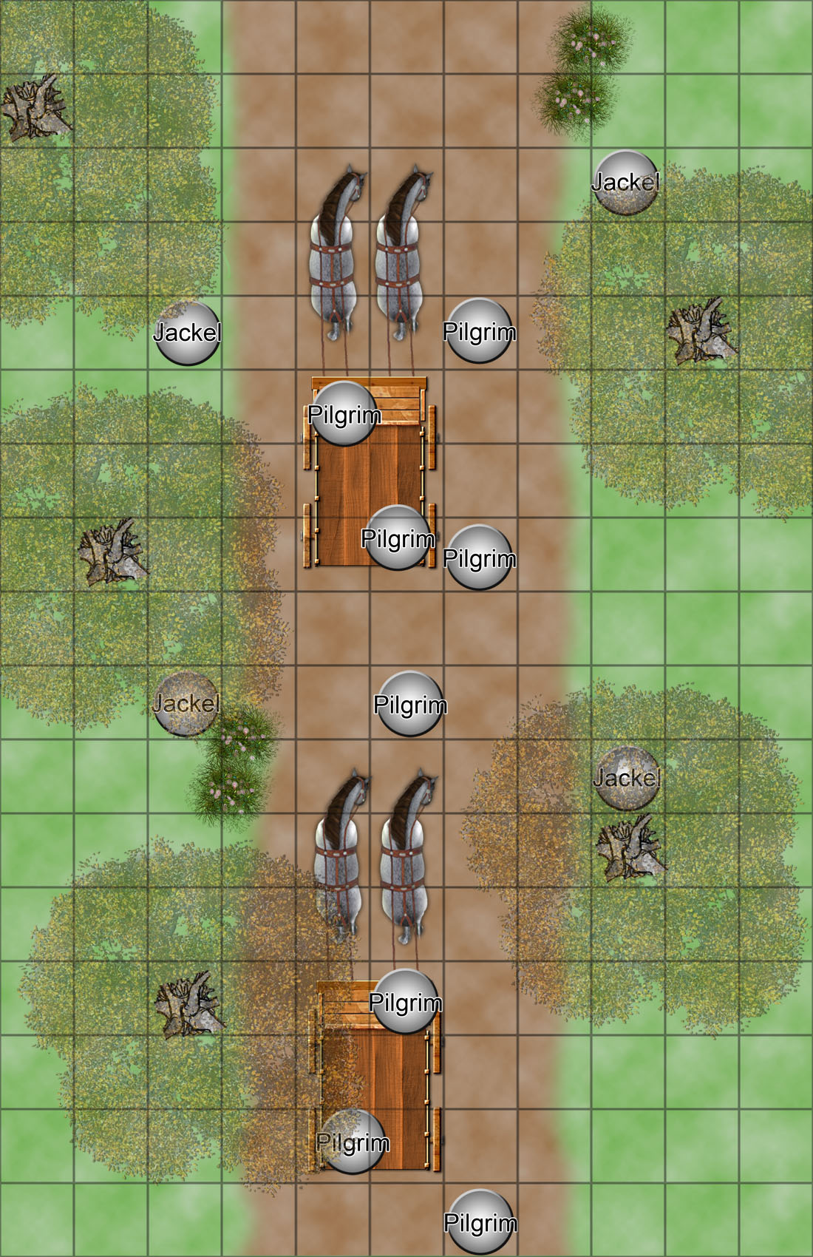
Adventure Map #2 – The Shrine
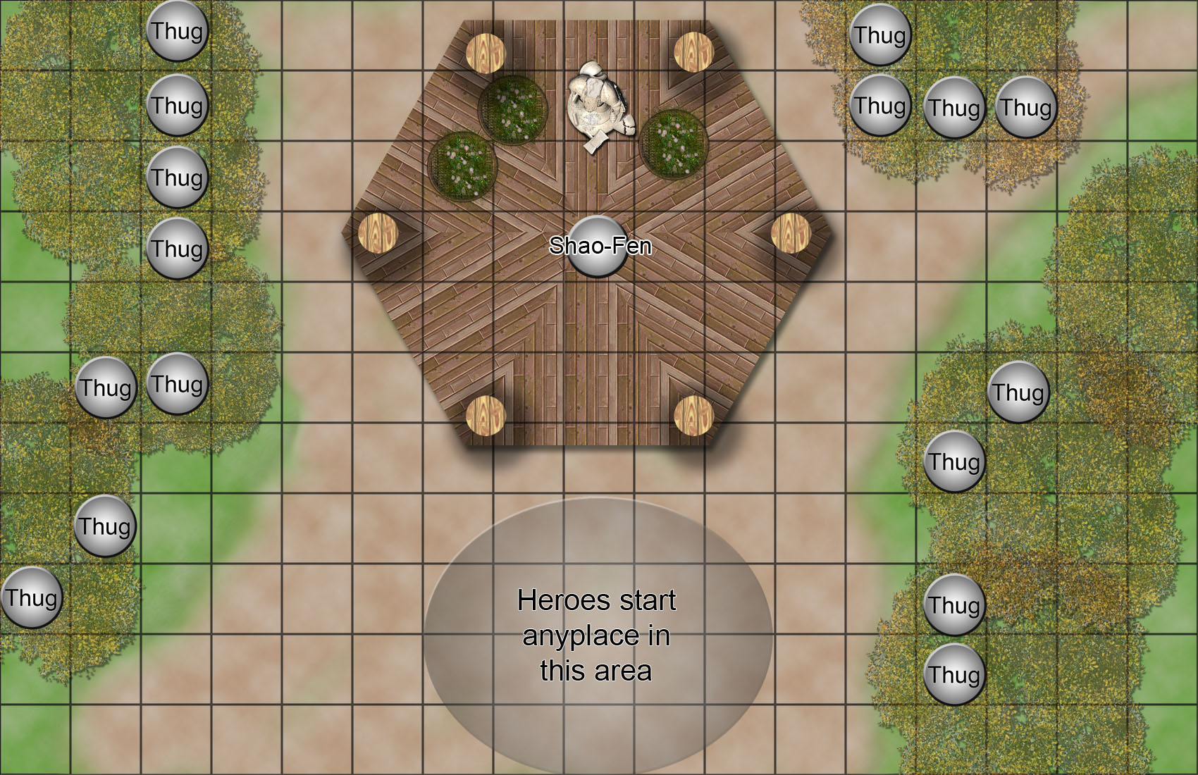

Adventure Map #3 – Ritual Location
